# Introduction:

We learned about different types of variables used in postman. Data files are also a way of passing the variables in different requests in postman. Data files are extremely powerful ways to test your APIs with varying data to check if they behave properly under unexpected circumstances.

Also Data Files are used to control the number of iteration of the collection run. Hence, we can think of data files are parameters for each iteration of a collection run.

Now let’s look into where are how data files are used in an API request with the help of the following example

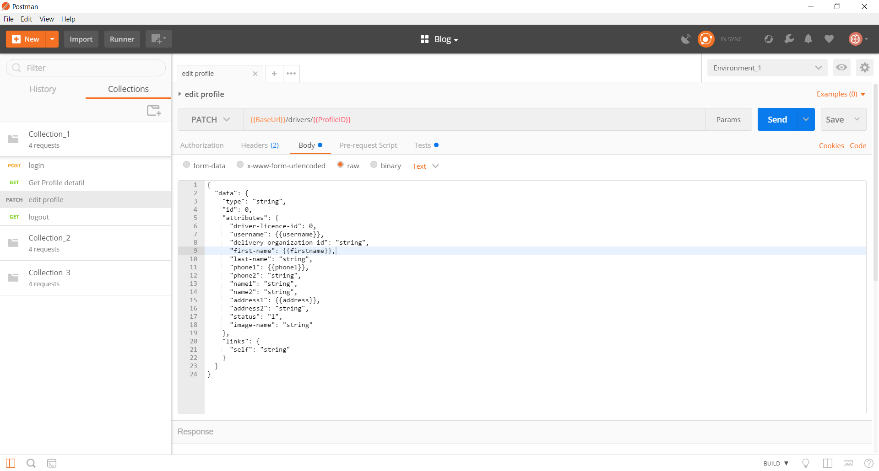

In the picture above notice that five data file variables are used. {{ProfileID}} in Request URL and {{username}}, {{firstname}}, {{phone1}} and {{address}} in the Request body section. Data files are passed in the request header same as in the request URL section. These are used just like the environment variables.

We will supply the value to these variables using a JSON / CSV file. Which brings us to our next topic.

## Creating a Data file:

Postman currently supports JSON & CSV files.

The JSON data file for the above variables will look like

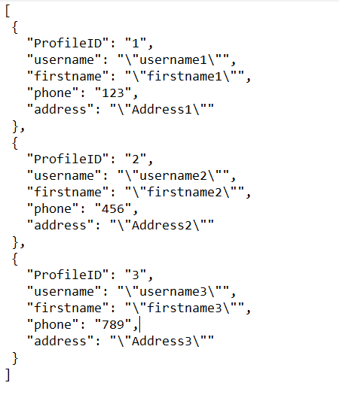

This is an array of objects. Each object represents the variable values for one iteration. Each member of this object represents a variable. In this way, in the first iteration, the variable called **ProfileID** will have the value 1 and variable **username** will have the value username1 and so on. Similarly, in the second iteration the variable **ProfileID** will have the value2 and the variable **username** will have the value username2 and so on. Note that the name of the variable in the postman app and the JSON file should exactly be the same.

Now let’s look at the CSV format. The CSV file for the above variables will look like.

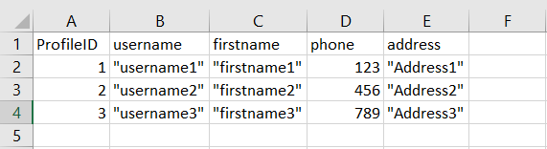

In the CSV format the first row represents the variable names and the following rows represent the values for these variables for each iteration. The number of row determine the number of iterations

Do note that you can use only one data file for one run, so put all the variables values in a single data file.

## Using Data files in Collection Runner:

Now that we have learned how to create a data file, let’s look into how to supply the data file in the collection runner.

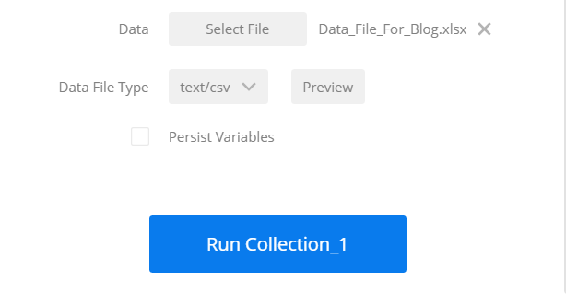

After choosing the Collection and the Environment, click on the Select File button of the Data field in the Collection Runner window and select your data file. Then select the file type (CSV or JSON) in the Data File Type field.

You can also preview what values each variable has in each iteration by clicking on Preview next to the file name.

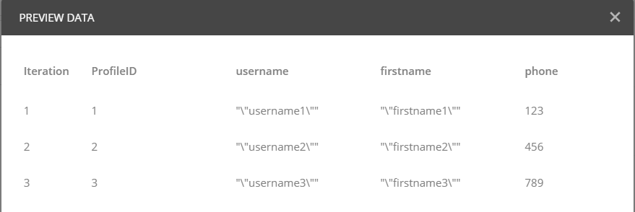

After you have chosen all the required fields, just click on the **Run** button to run the collection against the selected Data file.